Chapter 1
Company Profile

1.1 About the Company

GSSSIETW is located in Mysore, the city of Palaces, renowned as a seat of learning. Steeped in history, the city of the Wodeyars, Mysore continues to be the cultural capital of Karnataka.
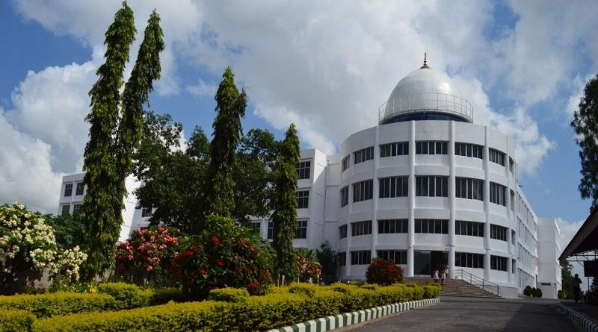 FIG 1.1: GSSS Institute of Engineering and Technology for Women.

Above shown fig 1.1 is the picture of GSSSIETW. Experiencing moderate climatic conditions throughout the year, Mysore is located in the southern part of Karnataka with an enchanting natural environment, most suitable for educational pursuits. Managed by the WHO'S WHO of Mysore, GSSS(R) is a non-profit organization which is focused towards value addition in terms of providing best of infrastructure and services for the cause of education. Women empowerment is a cliched slogan today.

But for Smt. Rukmini Bai Pandit educating the girl child and liberating her was a very valid cause for which she dedicated her entire life. Thus a technical institute exclusively for women, the first of its kind in Karnataka, is a fitting tribute to her memory and ideals.
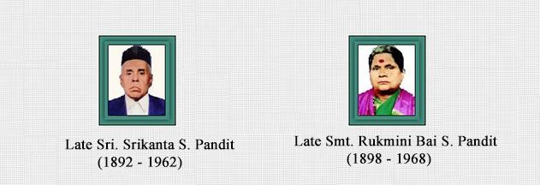
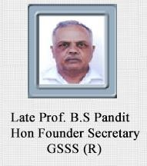

FIG 1.2: Founder of GSSSIETW.

GSSS (R) Geetha Shishu Shikshana Sangha (R) was founded by Prof. B.S.Pandit Retired Professor, from SJCE, Mysore & a true visionary. As an academician, worked for more than 4 decades in the line of technical education, started this first women's engineering college in Karnataka. With his leadership qualities, determination & dedication to serve for the cause of education, this institute is constantly upgrading its quality, infrastructure and other various developments according to present day needs.



FIG 1.3: Logo of GSSSIETW.

Vision:
"To become a recognized world class Women Educational Institution, by imparting professional education to the students, creating technical opportunities through academic excellence and technical achievements, with ethical values”.
Mission:
- To support value based education with state of art infrastructure.
- Το empower women with the additional skills for professional future career
- To enrich students with research blends in order to fulfill the International challenges.
- To create multidisciplinary center of excellence
- To achieve accreditation standards towards international education recognition
- To establish more post graduate & research course
- To increase Doctorates numbers towards the research quality of academics.

  - Organization Structure
GSSSITEW, Mysuru is governed by Smt.Vanaja B Pandit , who is the honorable secretary of GSSS. The prestigious college is also governed by the president, Dr. Jagganatha Shenoi M and vice president , Sri B Srinivasa Gupta. Dr. M Shivakumar is the principal of GSSSIETW.
The college has the following departments:

- Basic Science.
- Computer and science Engineering.
- Electronics and Communication Engineering.
- Information and Science Engineering.
- Electrical and Electronic Engineering.
- Electronics and Instrumentation Engineering.
- Telecommunication Engineering.

The following departments are managed by the individual Head of Departments. The college provides good hostel facility which comprises 3 blocks that can accommodate 400 students. Each hostel block has a hostel warden supervise the day to day management.
The college computer centre is equipped with state of the art infrastructure with a distributed computing environment to cater to the computing and networking needs of the students and staff of the college. The computer centre is networked with LAN and enjoys wireless facilities with recent configuration of IBM servers and protected using firewall.
The entire campus is provided with an internet bandwidth of 100 mega bits per second from BSNL (70 megabits per second in FTTH plan and 40 megabits per second in National Mission on Education Scheme through ICT plan).
Nearly 400 computers are networked with high speed LAN and the total campus is Wi-Fi enabled. Also, our college library is well maintained and modern. GSSS Institute of Engineering & Technology for Women is equipped with sewage Treatment Plant to minimize the use of potable water by recycling the sewage water collected from the hotel blocks, college and canteen.
Chairman
Management Committe

Principal

Office Manager
Manager Accountant
Librarian
Physical Instructor
Head of Department

Office staff
Assistant Librarian
HOD of ECE
HOD of CSE

HOD of ISE
Lab Assistant
Faculty
HOD of EEE
HOD of TCE
HOD of EIE

FIG 1.4: Organizational Structure.

1.3 Service Offered by the Company

The institute lays emphasis on providing value based education in the technical field. It guides students to become globally competent technocrats. It has highly qualified, experienced and dedicated faculty members. The institute provides opportunities for the overall development of the students through a number of cultural activities and sports.
1.3.1 Courses Offered
The GSSS Institute of Engineering and Technology for Women offers the following under graduate and post graduate courses:
Under Graduate Courses
B.E. in Electronics & Communication Engineering.
B.E. in Computer Science & Engineering.
B.E. in Information Science & Engineering.
B.E. in Electrical & Electronics Engineering.
B.E. in Electronics & Instrumentation Engineering.
B.E. in Telecommunication Engineering.
Post Graduate Courses
Master of Business Administration (MBA) (Co-Education on Separate Campus)
M. Tech in Digital Communications & Networking
M. Tech in Computer Science & Engineering

1.3.2 Infrastructure and Faculty

The GSSS Institute of Engineering and Technology for Women provides excellent facilities for the students. Among the long list of facilities provided by the institute are spacious and airy classroom, EDUSAT facilities, computer center, internet facilities throughout the campus, high-tech laboratory, well stocked library, digital library, workshops, meditation hall, large playground, sports facilities for outdoor games like cricket, badminton, volleyball, basketball, throw ball etc. Facilities for indoor gmes like chess, carom, table tennis.
Sports trainer is also available. It also consists of multi gym facilities. Large girl’s hostel with well furnished spacious room with attached bathroom. Kitchen with steam cooking facilities and hygienic vegetarian food facilities for hostel inmates. Solar water heater, medical care, canteen and coffee bar, elevator 24*7 power supply and secrurity and 13 college buses for transportation of students from various corners of Mysore.

1.3.3 Placement and Training Cell

There is a placement and training cell of the institute that trains students to face interviews. The placement cell invites various multinational companies for recruitment from among the students.

Some of the top recruiters of the institute include Infosys, IBM, SAP, Wipro, IGate, Tech Mahindra, Oracle, Syntel,
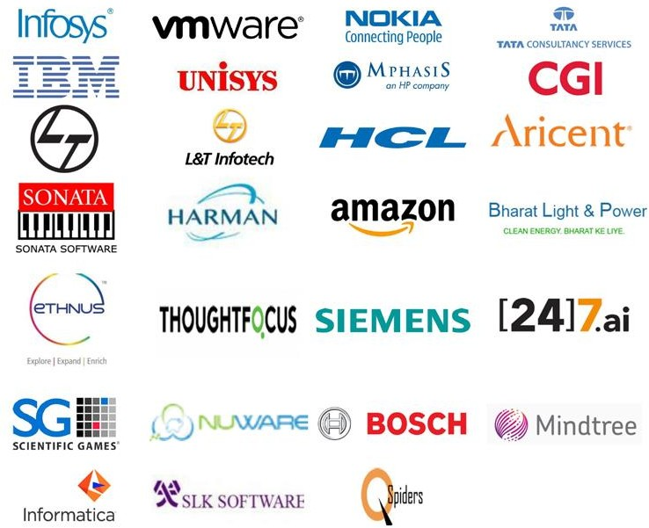
FIG 1.5: Frequently Visited Company.

1.4 My Internship Department / Section
The Department of Electronics and Communication Engineering at GSSSIETW was started in the year 2003. The ECE course is a four years Under-Graduate (UG) program in Bachelor of Engineering, affiliated to Visvesvaraya Technological University (VTU), Belgaum, approved by All India Council for Technical Education (AICTE), New Delhi. The ECE UG program is accredited by NBA, New Delhi (Validity: 01.07.2017 - 30.06.2020 & 01.07.2020 - 30.06.2023). Initially the intake was 60 and later the strength was increased to 120 in the year 2011 and then strength was increased to 180 in 2019.

The Department has 22 professionally qualified faculty members with various research specializations (Applied Electronics, VLSI Design and Embedded systems, Digital Electronics and Communication Systems, Computer Network Engineering, Industrial Electronics, Electronics, Image processing, Bio medical signal processing and instrumentation). The Department also comprises of experienced and skilled technical support staff. The student staff ratio has been maintained as per AICTE norms.
The department has established training placements and research labs such as Embedded Lab, IOT Lab, Intel Lab and Wireless Communication Lab with the latest technical tools for encouraging students and research scholars in updating their knowledge on the latest technology. The department has signed Memorandum of Understanding’s with many companies such as Kaaya Tech Inc., Mysuru, Kaynes Technology, Mysuru, Advanced Electronic Systems, Bengaluru, Roboguru mysuru with an initiative to organize workshops, seminars, faculty development programs and internships. VTU recognized Research Center is established in the department which facilitates faculty members to pursue their PhD. About ten faculty members are pursuing their PhD in various domains such as Image Processing, Nano Technology, VLSI, Antennas, Wireless Sensor Networks and Computer Network Engineering.

Chapter 2

INTERNSHIP DETAILS

2.1 Overview of the Work

This report includes knowledge about the speech signal processing and digital image processing using the tool MATLAB. It also includes the basic operations of MATLAB.

Signal and Image Processing:

The field of signal and image processing envelops the hypothesis and practice of algorithms and equipment that convert signals delivered by artificial or characteristic methods into a structure helpful for a particular reason. The signs may be discourse, sound, pictures, video, sensor information, telemetry, electrocardiograms, or seismic information, among others; potential purposes incorporate transmission, show, stockpiling, translation, order, division, or determination. In this field span the areas of digital signal processing, statistical signal processing, image/video compression, analysis & processing, speech processing, music information retrieval and computer audition.

MATLAB:

MATLAB, short for Matrix Laboratory is a programming package specifically designed for quick and easy scientific calculations and I/O. It has literally hundreds of built-in functions for a wide variety of computations and many toolboxes designed for specific research disciplines, including statistics, optimization, solution of partial differential equations, data analysis.

2.2 Details of the Work Performed

2.2.1 Introduction to Speech Mechanism
Speech is human vocal communication language. Speech is composed of a sequence of sounds. Sound is a characteristic type of correspondence for individuals, and computer with the capacity to get sound and talk with a human voice are relied upon to add to the advancement of more normal man-machine interfaces. Computer with this sort of capacity are bit by bit turning into a reality, through the advancement of combination of sound signal and sound recognition innovations.

2.2.2 Physiological Concepts of Speech Production
The vocal folds produce sound when they come together and then vibrate as air passes through them during exhalation of air from the lungs. This vibration produces the sound wave for your v
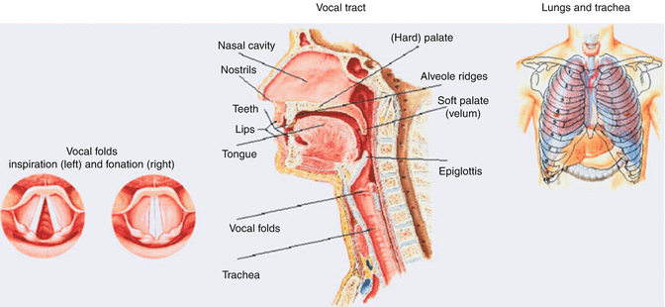
FIG 1.6: Human Vocal Tract

Fig 1.6 shows the pictorial representation of human vocal tract. Speech is produced as sequence of sounds. The articulators i.e. jaw, tongue, velum, lips, mouth and their shapes, sizes and positions changes over time to produce sounds.
In order for the sound to be clear and not raspy or hoarse, the vocal folds must vibrate together symmetrically and regularly. The rate of vibration determines the pitch of the voice. When the voice is hoarse, the vocal folds may not be closing fully, or may not be vibrating symmetrically. . In light of the physiological angles, we can separate the speech production cycle in three unique stages.
Conceptualisation: Sound production starts from brain which is basically considered as pre-verbal message and this process is called as conceptualisation.
Formulation: In speech process is formulation which converts the thoughts produced in the brain into linguistic form, this stage is called as speech formulation.
Articulation: In this stage sound will be produced to convey message.

2.2.3 Speech Signal Processing
Speech signal processing is the study of speech signal and extracting the same. These signals maybe of audio, video ,control, cardiogram etc. The signals are generally handled in an advanced portrayal. These signals are similar to natural language processing(NLP). The speech signal processing is done through three different ways
Speech Recognition
Speech Synthesis
Speech Compression

Speech Recognition:
Speech recognition is often called as vocal recognition which mainly concentrate on collecting human voices or the voices from the different device where the signal as to be processed. The recognition system is trained, in case of the where the signal as to be processed. The recognition system is trained, in case of the computer, recognition software is being installed where it detects the individual voice, person who is talking and more likely perceive what is being said. Voice recognition is the system trained to particular user where it recognises the voices based on the vocal sound.

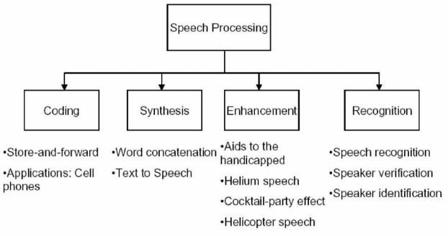
FIG 1.7: Block Diagram of Speech Signal Processing

Speech Synthesis
The counterfeit creation of human speech is known as the speech synthesis. A computer framework utilized for this design is known as a speech synthesizer, and can be executed in programming or in equipment. It is the opposite cycle of speech recognition and advances in the region to improve the computer ease of use for the outwardly hindered. A text to-speech (TTS) system changes over typical language text into speech, different frameworks render symbolic linguistic portrayals like phonetic records into speech.
Synthesized speech can be created by concatenating pieces of recorded speech that are stored in the database. For specific usage domains, the storage of entire words or sentences allows for high-quality output. Alternatively, a synthesizer can incorporate a model of the vocal tract and other human voice characteristics to create a completely "synthetic" voice output. The quality of speech synthesizer is judged by its similarity to the human voice.

Speech Compression

Speech Compression is a field of digital signal processing that focuses on reducing bit- rate of speech signals to enhance transmission speed and storage requirement of fast developing multimedia.
It is very important in the telecommunications area for increasing the amount of information which can be transferred, stored, or heard, for a given set of time and space constraints. The compression of speech signals has many practical applications. One example is in digital cellular technology where many users share the same frequency bandwidth. Compression allows more users to share the system than otherwise possible. Another example is in digital voice storage (e.g. answering machines). For a given memory size, compression allows longer messages to be stored than otherwise.
Speech Recognition
Speech recognition (SR) is the translation of spoken words into text. It is also known as "automatic speech recognition" (ASR), "computer speech recognition", or just "speech to text" (STT). Speech recognition process can be done by different steps they are:
- End point detection
- Frame blocking and windowing
- Feature extraction
- Distortion measure calculation

Glottal pulse model
Impluse train genarator
Radiation model
Vocal tract model

Random noise generator

FIG 1.8: Speech Production Model

Two important forms of speech signal processing techniques are
- Time domain method: works directly on speech signal
- Frequency domain method: work on spectrum

2.2.4 Time domain method

Time domain methods are chosen over frequency domain method because of following reasons
- Easy implementation
- Application of mathematics concepts are very less used
- Hardware requirement is less for real time application(Embedded system)

Short-Time Speech Analysis

Speech is a time varying and the model parameters are also time varying, therefore to analyze a speech signal short-time analysis to estimate the speech signal. Moreover, from speech samples to model parameters, alternative short-time representations are often require.
aAA

Parameter Estimation
Short-time analysis

Speech w/fm Alternate representation

FIG 1.9: Short-time Speech Analysis for Parameter Estimation

Assumption:

Properties of speech signal changes frequently, hence let’s assume that the properties of speech signal change relatively slow compared to the sampling rate of the speech waveform. With rate of change on the order of 10-30 times per second, corresponding to the rate of speech 5-15 phones per second.

Basic Framework:
A speech signal is divided into short segments, each of which is expected to be similar from a sustained sound. Such a segment is called as a frame. The frames are utilized to recognize the sounds, which are incorporated to be the speech.

General Representation of Short Time Processing

Low pass filter
W()
T()
Linear Filter

FIG 1.10: General Representation of Short-time Analysis

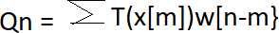
Short –time processing can be represented in mathematical form and as show below

In the above equation, T() is meant to extract certain features of the speech signal. The features is then summed over a window w [n − m] anchored at n. The result is a short- time feature near n.

Short Time Energy

Amplitude of speech varies considerably with time. Hence Short term energy can be used to classify speech as voiced or unvoiced. Short time energy is defined as
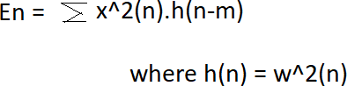

Without additive noises, En is useful in detecting voiced segments of speech. It is also useful to detect silence segments.
Magnitude The short-time magnitude is similar to the short-time energy. Only (·)^ 2 is replaced by | · |.

Zero crossing rate
For discrete-time signals, a zero-crossing occurs if two adjacent samples are of different signs. Consider a sinusoidal wave xc(t) of frequency F0. If the sampling period T is not longer than half the period 1/2F0, then the number of zero-crossing per second of x[n] = xc(nT) is 2(F0), since there are two zero-crossing in x[n] per cycle of xc(t) and there are F0 cycles per second. The number of zero-crossings per sample is
where Fs is 1/T is the sampling frequency.

2.2.5 Application of Speech Signal Processing
Interactive voice response (IVR)
IVR is an innovation that permits people to collaborate with a computer worked telephone framework using voice and DTMF tones input through a keypad. In broadcast communications, IVR permits clients to cooperate with an organization's host framework by means of a phone keypad or by speech recognition, after which administrations can be asked about through the IVR exchange. IVR frameworks can react with pre-recorded or progressively produced sound to additional immediate clients on the most proficient method to continue. IVR frameworks sent in the organization are estimated to deal with huge call volumes and furthermore utilized for outbound calling as IVR frameworks are more intelligent than numerous prescient dialer frameworks.

Virtual Assistants

An intelligent virtual assistant (IVA) or intelligent personal assistant (IPA) is a product operator that can perform undertakings or administrations for an individual dependent on orders or questions. Now and then the expression "chatbot" is utilized to allude to remote helpers by and large or explicitly got to by online visit. In some cases, online chat programs are exclusively for entertainment purposes. Some virtual assistants are able to interpret human speech and respond via synthesized voices. Users can ask their assistants questions, control home automation devices and media playback via voice, and manage other basic tasks such as email, to-do lists, and calendars with verbal commands.

2.2.6 Introduction to MATLAB
The name MATLAB stands for Matrix Laboratory. MATLAB was written originally to provide easy access to matrix software developed by the LINPACK (linear system package) and EISPACK (Eigen system package) projects.
MATLAB is a high-performance language for technical computing. It integrates computation, visualization, and programming environment. Furthermore, MATLAB is a modern programming language environment: it has sophisticated data structures, contains built-in editing and debugging tools, and supports object-oriented programming. These factors make MATLAB an excellent tool for teaching and research.
MATLAB is a high performance language for technical computation. It coordinates calculation, representation, and programming environment. Moreover, MATLAB is a current programming language climate: it has complex information structures, contains worked in altering and troubleshooting apparatuses, and supports object-arranged programming. These components make MATLAB a fantastic device for educating and examination.
It has powerful built-in routines that enable a very wide variety of computations. It also has easy to use graphics commands that make the visualization of results immediately available. Specific applications are collected in packages referred to as toolbox. There are toolboxes for signal processing, symbolic computation, control theory, simulation, optimization, and several other fields of applied science and engineering.

Windows of MATLAB
When we start MATLAB, a special window called MATLAB desktop appears. In this desktop window it contains other windows. The major tools among them are as follows:
- The Command Window
- The Command History
- The Workspace
- The Current Directory
- The Help Browser
- The Start button
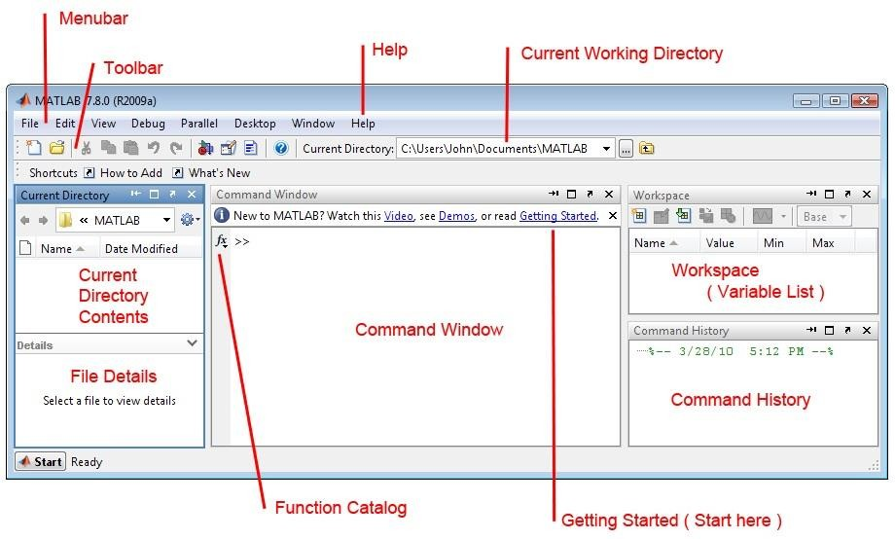
FIG 1.10: The Graphical interface to the MATLAB workspace

When MATLAB is started for the first time, the screen looks like the one that shown in the Fig. 1.10. This illustration also shows the default configuration of the MATLAB desktop. We can also customize the arrangement of tools and documents to suit our needs.

Managing the workspace

The command clear or clear all removes all variables from the workspace. This frees up system memory
>>clear

In order to display a list of the variables currently in the memory, who will give more details which include size, space allocation, and class of the variables.
>>who

Getting help

To view the online documentation, select MATLAB Help from Help menu or Help directly in the Command Window. The preferred method is to use the Help Browser. The Help Browser can be started by selecting the help icon from the desktop toolbar. On the other hand, information about any command is available by typing,
>>help command
Another way to get help is to use the lookfor command. The lookfor command differs from the help command. The help command searches for an exact function name match, while the lookfor command searches the quick summary information in each function for a match.

>>lookfor
The following table displays some commonly used system-related commands.

Command Function
Cd | Changes current directory.
Date | Displays current date.
delete | Deletes a file.
diary | Switches on/off diary file recording.
Dir | Lists all files in current directory.
Load | Loads workspace variables from a file.
Path | Displays search path.
Pwd | Displays current directory.
Save | Saves workspace variables in a file.
Type | Displays contents of a file.
what | Lists all MATLAB files in the current directory.
wklread | Reads .wk1 spreadsheet file.

Table 1: Commonly used Commands in MATLAB

2.2.7 Digital Image Processing

Digital image processing is the use of a digital computer to process the digital images through an algorithm. Digital image processing deals with manipulation of digital images through a digital computer. It is a subfield of signals and systems but focus particularly on images. DIP focuses on developing a computer system that is able to perform processing on an image. The input of that system is a digital image and the system process that image using efficient algorithms, and gives an image as an output.
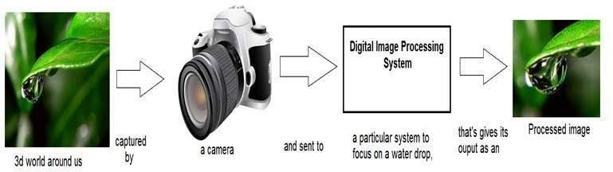

FIG 1.12: Simple working process of image processing

In the above figure, camera capturer an image and send the captured image to the digital image processing system. In digital image processing system, it removes the entire unwanted images portion and retains the required image segments.

2.2.7.1 Fundamentals of Digital Image Processing:

Image Acquisition:

The image is captured by a sensor (eg. Camera), and digitized if the output of the camera or sensor is not already in digital form, using analogue-to-digital convertor.
Preprocessing
Cropping: The basic type of preprocessing refers to image cropping. Cropping refers to the removal of the outer parts of an image to improve framing, accentuate subject matter or change aspect ratio. In other words, it refers to removing unwanted areas from a digital image capture. This is needed in the project in the part of the vehicle registration plate.
Image cropping can be performed either by manually or by defining the selected spatial coordinates [a b c d], a is the pixels from left, b is the pixels from bottom, c is the width of the selected area, and finally d is the height of the selected area.

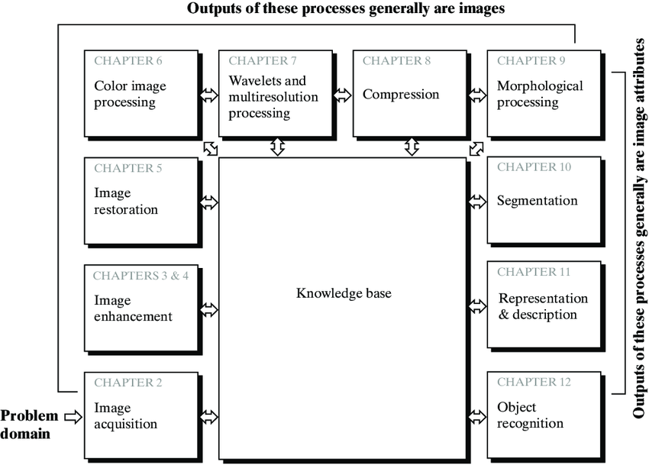
FIG 1.13: Fundamentals Steps of Digital Image Processing.

Image Enhancement:
It is among the simplest and most appealing areas of digital image processing. The idea behind this is to bring out details that are obscured or simply to highlight certain features of interest in image. Image enhancement is a very subjective area of image processing.
Image processing is the procedure of improving the quality and information content of original data before processing. Common practices include contrast enhancement, spatial filtering, density slicing, and FCC. Contrast enhancement or stretching is performed by linear transformation expanding the original range of gray level. Spatial filtering improves the naturally occurring linear features like fault, shear zones, and lineaments. Density slicing converts the continuous gray tone range into a series of density intervals marked by a separate color or symbol to represent different features.


FIG 1.14: Example for Image Enhancement

Color image processing:
It is an area that is been gaining importance because of the use of digital images over the internet. Color image processing deals with basically color models and their implementation in image processing applications.\

Wavelets and Multi resolution Processing :

These are the foundation for representing image in various degrees of resolution

Compression:
It deals with the techniques that deals with reducing the storage required to save an image, or bandwidth required to transmit it over the network. It has two major approaches are Lossless compression and Lossy compression.

Morphological processing:

It deals with tools for extracting image components that are useful in the representation and description of shape and boundary of objects. It is majorly used in automated inspection applications.

Representation and Description:

It always follows the output of segmentation step that is, raw pixel data, constituting either the boundary of an image or points in the region itself. In either case converting the data to a form suitable for computer processing is necessary.

Recognition:

It is the process that assigns label to an object based on its descriptors. It is the last step of image processing which use artificial intelligence of software’s.

Knowledge base:

Knowledge about a problem domain is coded into an image processing system in the form of a knowledge base. This knowledge may be as simple as detailing regions of an image where the information of the interest in known to be located. The knowledge base also can be quite complex such interrelated list of all major possible defects in a materials inspection problems or an image database containing high resolution satellite images of a region in connection with change detection application.

2.2.7.2 Digital Filter

A digital filter uses a digital processor to perform numerical calculations on sampled values of the signal. The processor may be a general-purpose computer such as a PC, or a specialized DSP (Digital Signal Processor) chip.
Digital i/p Digital o/p
Digital Filters

FIG 1.15: Block diagram of Digital Filter

Operation of Digital Filter:

Suppose the "raw" signal which is to be digitally filtered is in the form of a voltage waveform described by the function
V = x(t)

where t is time.

This signal is sampled at time intervals h (the sampling interval). The sampled value at time t = ih is
xi = x(ih)

Thus the digital values transferred from the ADC to the processor can be represented by the sequence
x0 , x1 , x2 , x3 , ...
corresponding to the values of the signal waveform at t = 0, h, 2h, 3h, ...
and t = 0 is the instant at which sampling begins.

Application of Digital Filter:

Loudspeaker Equalization Example:
The objectives of this equalization is to reduce the variations in the overall frequency response, extend the low frequency response, and improve the power handling of low frequency information. The improvement in the power handling of low frequency information is needed to eliminate distortion and noise that is produced by the loudspeaker by 50 Hz and lower tones when played at levels exceeding 15 watts.
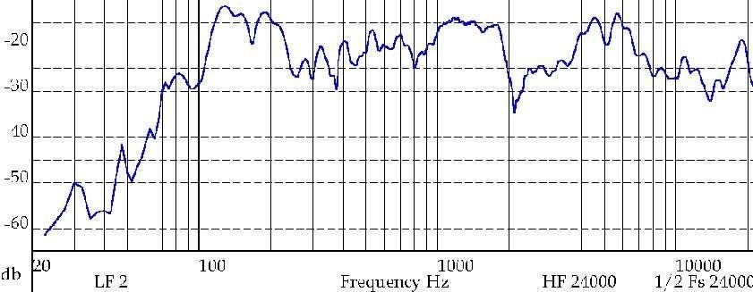
FIG 1.16: Frequency Response of Monitor Loudspeaker
Noise Suppression:

Noise suppression is a very common technique in chromatographic data processing. It aims to enhance an analytical signal to give a higher signal-to-noise ratio. Nowadays, many chromatographic instruments are controlled by computers and it has become a common practice to reduce the noise by employing digital processing methods such as filtering. Traditionally, analytical chemists favor the adoption of the Savitzky–Golay, Fourier, and Kalman filters for signal processing. After the introduction of the WT technique to analytical chemistry, some workers found that the performance of WT is much better than that from the above mentioned filters in data devoicing.

FIG 1.17: Noise Suppression

Bandwidth Limit: To prevent interference of different TV and Radio channels.
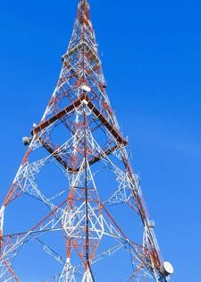

FIG 1.18: Bandwidth limit

Histogram:
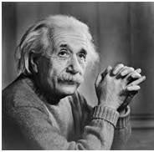
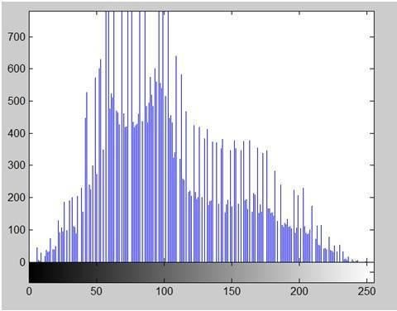
An image histogram is a type of histogram that acts as a graphical representation of the tonal distribution in a digital image.It plots the number of pixels for each tonal value. By looking at the histogram for a specific image a viewer will be able to judge the entire tonal distribution at a glance. Usually histogram has bars that represent frequency of occurring of data in the whole data set.

FIG 1.19: Image Histogram

The histogram of the picture of the Einstein is shown in figure. The x axis of the histogram shows the range of pixel values. Since it is a 8 bits per pixel image, that means it has 256 levels of gray or shades of gray in it. It is reasoon why the range of x axis starts from 0 and end at 255 with a gap of 50. Whereas on the y axis, it is the count of these intensities.
From the above we can infer that, most of the bars that have high frequency lie in the first half portion which is the darker portion. That means that the image we have got is darker. And this can be proved from the image too.

Application of Histogram:

- Histogram has many uses in image processing. The first use as it has also been discussed above is the analysis of the image. We can predict about an image by just looking at its histogram. It like looking an x ray of a bone of a body.
- The second use of histogram is for brightness purposes. The histogram has wide application in image brightness. Not only in brightness, but histograms are also used in adjusting contrast of an image.
- Another important use of histogram is to equalize an image. Histogram has wide use in thresholding. This is mostly used in computer vision.

Music signal processing:

The sound produced by acoustic musical instruments is caused by the physical vibration of a resonating structure. This vibration can be described by signals that correspond to the evolution in time of the acoustic pressure generated by the resonator. The fact that sound can be characterized by signals suggests quite naturally that computing equipment could be successfully employed for generating sounds, either for the imitation of acoustic instruments or the creation of new sounds with novel timbral properties.
A wide variety of sound synthesis algorithms are currently available either commercially or in the literature. Each exhibits characteristics that could make it preferable to others, depending on one’s goal and needs. Technological progress has made enormous steps forward in the past few years in terms of delivering low-cost computational power. At the same time, sound synthesis methods have become more and more computationally efficient and the user interface has become “friendlier”. As a consequence, musicians can without an enormous investment access a large collection of synthesis techniques and concentrate on exploring their timbral properties.

Experience of work:

Regularly, we think coddled is the best approach to learn, however working autonomously make us to learn numerous things. This entry level position helped me to settle on my own choices and permits me to think distinctive route separated from genuine schedule. Working autonomously alongside the direction is the primary concern in the current situation. It helped me to comprehend idea all the more obviously. Application to hypothetical ideas was examined which some of them were risky and henceforth it was an opportunity to build up my critical thinking aptitudes. This temporary job additionally showed me the demonstrable skill and times the executives, which are primary characteristics a representative ought to have.
I can unhesitatingly guarantee that the information I have increased through this entry level position has given me exceptionally supportive in contributing toward my future undertakings. This temporary job gave me new bits of knowledge and inspiration to proceed in hardware side.

Summary:
In this internship I was able to learn about:

- Speech signal
- Avenues of speech signal
- Speech signal processing
- Introduction to MATLAB
- Basics commands of MATLAB
- Image Processing
- Digital image processing
- Digital filter
- Histogram
- Music signal processing

Chapter 3

Reflection notes

Technical Outcome

- My internship at GSSSIETW was very interesting, informative and wonderful experience.
- In this internship I learnt about the tools used for processing the signal and image and I also get to know about different algorithms used for the processing.
- I learnt about the digital filter which is used for the processing of image signals and also gained knowledge about the applications of digital filter used in real world technologies.
- I gained knowledge about some of the basic codes used in MATLAB which is used in signal and image processing.

Personality development:

Experience: I learnt about different and interesting concepts in this internship which thought me a great experience.
Competitive Edge: This internship helped me to understand the present scenario in world for image and signal processing.
Career Exploration: I came to know about the career opportunities in this field and the options present in this field.
Communication skills: I could communicate more efficiently and exhibit my interpersonal skills.
This internship helps to master professional soft skills such as problem solving, critical thinking and time management.

Time management:

Time management is the most valuable thing in today’s world. With this internship I used to set short goals and I used to solve it by smart methods. I learnt to prioritize the tasks given based on the importance and urgency and remove the non-essential tasks by giving importance to the present given tasks. I used to organize myself by giving time to learn things and simultaneously taking break in between.

Skills Developed:
Technical skills: Gained ample knowledge on software such as MATLAB and prant software. And also gained knowledge on signals, image processing and their application
Inter-Personal Skills: Maintained a good inter personal relation with all the people around.
Communication Skill
Time Management Skill

Chapter 4
Conclusion:
Whole experience of this internship was useful and informative. I gained new knowledge and also learnt about new concepts. I studied more about image and signal processing and how it is processed and its applications
This internship was helpful in knowing about the skills and the concepts which is required to improve in coming time and also what are the current industry trends in this concepts and what we should need to be updated with.
At last in this internship has given me new insights and motivation to pursue a career in core electronics department and sufficient knowledge on signal and Image processing.

Reference:

- http://www.geethashishu.in/
- https://www.tutorialspoint.com/dip/histograms_introduction.htm
- ieeexplore.ieee.org
- en.wikipedia.org
- https://www.researchgate.net/publication/318500799_Image_Acquisit ion_and_Techniques_to_Perform_Image_Acquisition

